Experiment -2
Experiment 2: Stages of Compilation and Execution of a C Program

Aim:
To demonstrate the different stages of compilation of a C program using the -save-temps option and execute a C program to calculate the area of a circle.

Software/Environment:
Kali Linux, GCC compiler, Terminal.
Procedure:
Write the C program, compile it using gcc -save-temps, examine the intermediate files generated, and finally execute the program.
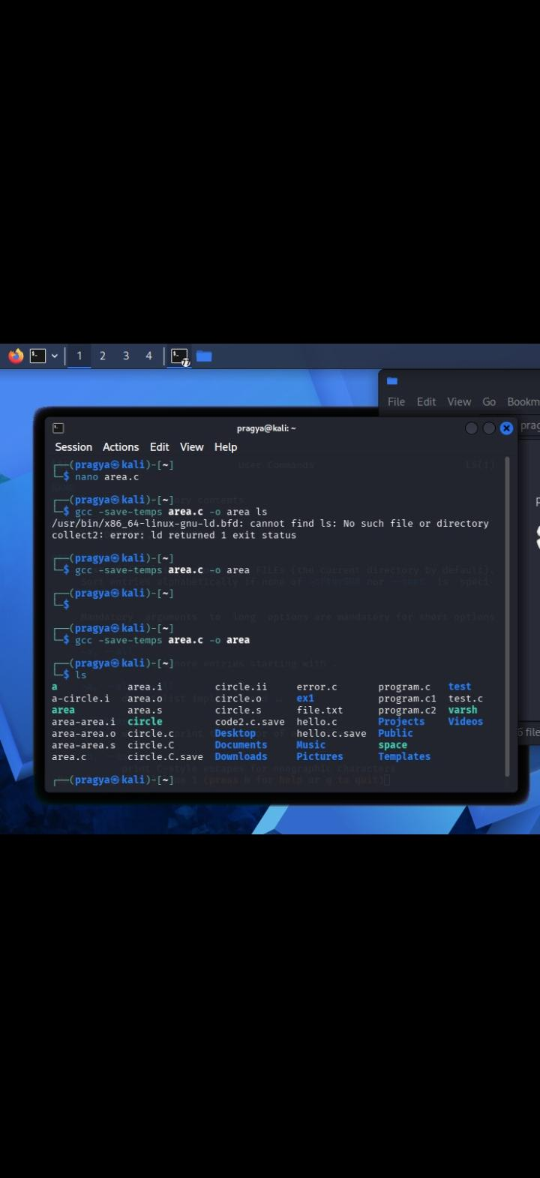
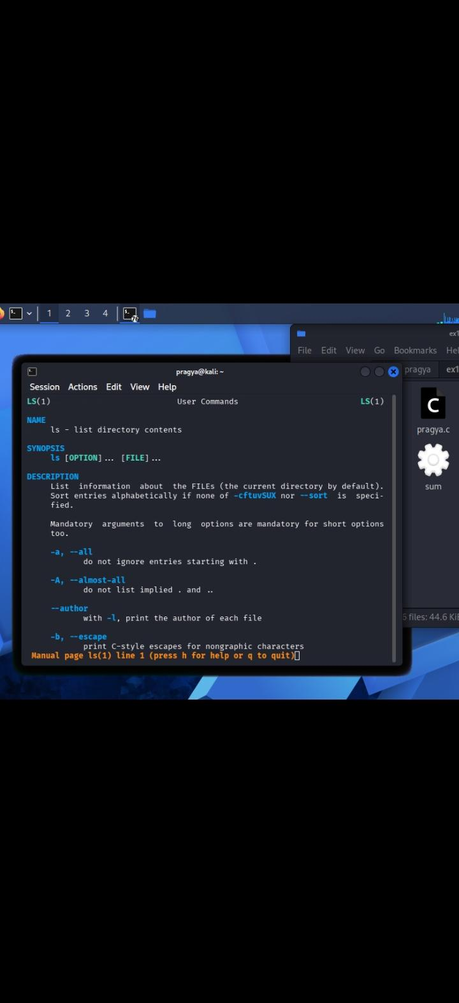

#include <stdio.h>
This header file is included to use standard input and output functions like printf() and scanf().
int main()
It is the main function from where the execution of the C program starts.
float radius, area;
Here, two variables radius and area are declared with float data type because their values can contain decimal numbers.
printf("Enter radius of circle: ");
This statement displays a message on the screen asking the user to enter the radius of the circle.
scanf("%f", &radius);
This statement takes the radius as input from the user and stores it in the radius variable. %f is used for float values.
area = 3.14 * radius * radius;
This statement calculates the area of the circle using the formula:
Area = π × r × r
Here, the value of π is taken as 3.14.
printf("Area of circle = %.2f\n", area);
This statement displays the calculated area. %.2f shows the answer up to two decimal places.
return 0;

It indicates that the program has executed successfully without any error.
In short: The program takes the radius from the user, calculates the area using 3.14 × radius × radius, and displays the final area on the screen.
This code is as follows
#include <stdio.h>

int main()
{
float radius, area;

printf("Enter radius of circle: ");
scanf("%f", &radius);

area = 3.14 * radius * radius;

printf("Area of circle = %.2f\n", area);

return 0;
}

Commands Used
Firstly file create/open while typing nano circle.c
nano circle.c
Code saved then
gcc -save-temps circle.c -o circle
Generated files checked
ls
Mostly this file will be show in this :
circle.c -> Source file
circle.i -> Preprocessed file
circle.s -> Assembly file
circle.o -> Object file
circle -> Executable file
To execute this program:
./circle
Example output:
Enter radius of circle: 5
Area of circle = 78.50
Result:
Thus, we successfully studied the different stages of compilation using the -save-temps option. We also compiled and executed a C program to calculate the area of a circle.
Thank you:
Name:pragya pandey
Course:btech(cse)
Sap id:590034352

